FOR IMMEDATE RELEASE Contact: Rick Williams
December 13th, 2021 802-626-5000

NVU-Lyndon Upward Bound Students Tour Saint Anselm College
Lyndonville – On Friday, December 10th, three Northern Vermont University – Lyndon Upward Bound students decided to spend the cold winter day touring Saint Anselm College. Located in Goffstown, NH, Saint Anselm College is a private, Benedictine, Liberal Arts College which offers a wide variety of undergraduate majors, Division II athletics, and many different clubs and activities for their students.
The Upward Bound students, Charlie, Jayden, and Thomas, spent the two hour drive south talking about what they hoped to learn about the college on the tour. All three students are high school juniors with interests in engineering, psychology, and pre-medical studies respectively. They brainstormed questions that they planned to ask the tour guide and talked through the pros and cons of different colleges.
Upon arrival to campus, the students were greeted by a member of the Admission’s team who is a proud alumna of the college. She welcomed the students and gave them a brief presentation on the school. She spoke about Saint Anselm’s financial aid process, their acceptance criteria, and life on the campus. Following this presentation, the students were introduced to their tour guide – a senior in the Politics Department – before setting off to see the campus.
The tour guide was incredibly personable, asking the students about their college and career goals. She tailored the tour to their interests and showed a majority of the sprawling campus. Students were able to see many of the dining facilities, the athletic facilities, some classrooms and laboratories, the library, a dormitory, and more. The guide answered many of the student’s questions and shared anecdotes about her time at the college.
At the conclusion of the tour, the students were given one last opportunity to ask any questions and were offered stickers, lanyards, and other swag as parting gifts. Before returning to the NVU-Lyndon campus, the students were treated to lunch at Applebee’s in Manchester where they were able to debrief about the experience and share what they did and did not like about the school. The ride home was punctuated by even more conversations about their college aspirations. Overall, the students had a great day and really enjoyed learning about everything Saint Anselm College has to offer!
Upward Bound at Northern Vermont University - Lyndon is a college preparatory program funded through the United States Department of Education. The program is committed to providing modest income, first in family, college bound students with the academic background, college preparatory experiences, and support to succeed in college immediately after high school. The Upward Bound program works with 75 students in 8 area high schools who are dedicated to achieving their post-secondary dreams. For more information, please contact Rick Williams in the Upward Bound Office at 626-5000.

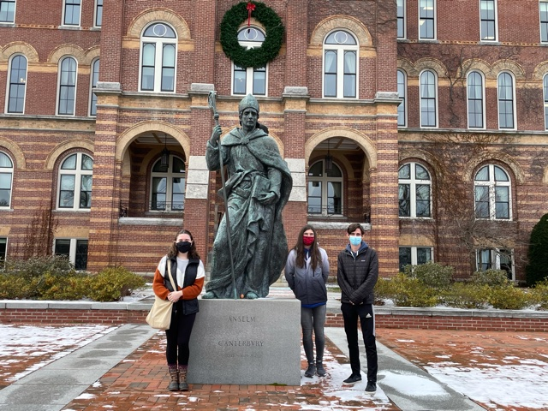

Upward Bound Students at Saint Anselm College (From Left to Right):
Jayden Riendeau, Junior, Canaan High School
Thomas Hinton, Junior, Lake Region Union High School
Charles Krebs, Junior, Craftsbury Academy

